SCHOOL ADMINISTARATION

Ch.Karthik Varma,
P.Siva Kumar Reddy
dept. name:School of computing and data science
sai university
City, Country
email address or ORCID

I.ABSTRACT
This project presents a School Administration System implemented in the C programming language using a Binary Search Tree (BST) data structure. The system efficiently manages student records by supporting operations such as insertion, deletion, searching, updating, and traversal. It incorporates dynamic memory allocation for handling strings and ensures memory safety through proper deallocation. Additional features include grade calculation, topper identification, filtering students based on marks, and counting total records. The use of BST enables efficient data organization and retrieval, making the system suitable for small to medium-scale academic institutions.
Keywords
Binary Search Tree, Student Management, Dynamic Memory Allocation, CRUD Operations, C Programming.
II.INTRODUCTION
Efficient management of student data is essential in educational institutions. Traditional methods of maintaining records manually are prone to errors and inefficiencies. This project introduces a digital solution using the C programming language, leveraging the Binary Search Tree (BST) data structure to store and manage student records.
The BST allows for efficient insertion, deletion, and searching operations with an average time complexity of O(log n), making it suitable for structured data storage. This system provides a simple and effective console-based application for managing school records.
III.OBJECTIVES
The main objectives of this project are to implement a student management system using BST, perform CRUD operations efficiently, demonstrate dynamic memory allocation in C, calculate grades based on student marks, identify the topper among students, and filter students based on marks.
IV.SCOPE PROJECT
This project is designed for academic learning and small-scale applications. It can be used in schools for managing student data and for understanding data structures like BST and memory management in C. However, it is limited to a console-based interface, does not support large-scale databases, and does not include persistent storage.

V.LITERATURE REVIEW
Binary Search Trees are widely used for hierarchical data storage due to their efficiency in search, insertion, and deletion operations. Standard data structure literature highlights BST as a fundamental concept for organizing data. While modern systems use databases, this project focuses on in-memory data handling using C. Compared to arrays and linked lists, BST provides better performance for sorted data operations. Dynamic memory allocation using functions like malloc() and free() is also a key concept in C programming.
VI.METHODOLOGY
The system is developed using a structured approach. First, a student structure is defined to store relevant data. Then BST operations such as insertion, searching, and deletion are implemented. Additional utility functions like grade calculation and display are added. Advanced features like topper detection and filtering based on marks are incorporated. Memory management is handled carefully using dynamic allocation and deallocation functions.
VII.TECHNOLOGY USED
The project is implemented using the C programming language. It can be compiled using compilers such as GCC or Turbo C. The main concepts used include Binary Search Trees, dynamic memory allocation, recursion, structures, and pointers.
VIII.ARCHITECTURE / SYSTEM DESIGN
The system is based on a Binary Search Tree structure where each node represents a student. Each node contains a unique student ID, name, age, marks, and pointers to left and right child nodes. The left subtree contains students with IDs less than the root, and the right subtree contains students with IDs greater than the root. The system is divided into input, processing, and output modules.
IX.IMPLEMENTATION DETAILS
The implementation includes several key components. A structure is defined to represent student data. The insert function adds new students while maintaining BST properties. The search function locates students using their ID. The delete function removes students and handles different cases such as leaf nodes and nodes with one or two children. The update function modifies existing student data. Inorder traversal is used to display records in sorted order. A grade calculation function assigns grades based on marks. Memory is managed using malloc() for allocation and free() for deallocation to avoid memory leaks.

X.RESULTS / OUTPUT
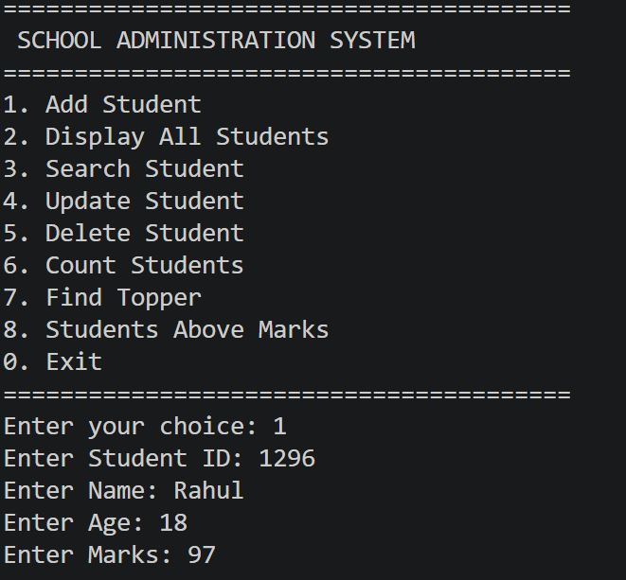
XI.CONCLUSION
This project successfully demonstrates the use of Binary Search Trees for managing student records. It highlights efficient data handling and the importance of dynamic memory management in C. The system is suitable for small-scale applications and serves as a strong foundation for learning data structures and algorithms.
XII.FUTURE WORK
Future improvements can include adding a graphical user interface, implementing file handling for data persistence, using self-balancing trees such as AVL or Red-Black Trees, integrating database systems, and adding user authentication and security features.
XIII.REFERENCES

[1] T. H. Cormen, C. E. Leiserson, R. L. Rivest, and C. Stein, Introduction to Algorithms, 4th ed., MIT Press, 2022. https://mitpress.mit.edu/9780262046305/introduction-to-algorithms/
[2] B. W. Kernighan and D. M. Ritchie, The C Programming Language, 2nd ed., Prentice Hall, 1988. https://openlibrary.org/books/OL24604598M/The_C_Programming_Language

.

